Data Flow Diagram
Date | 07 July 2026
Team ID | AIML-HDI-2026
Project Name | A Comprehensive Measure of Well-Being
Maximum Marks | 2 Marks

Data Flow Diagram
Create a Data Flow Diagram (DFD) to show how data moves through your system — between external entities, processes, and data stores. Use the symbol legend below as a guide.

DFD Symbol Legend
Symbol | Name | Description
Oval / Rounded shape | External Entity | The end-user who inputs socio-economic variables and receives the HDI forecast.
Rectangle with numbered header | Process (1. GPU Preprocessing, 2. Feature Mapping & Scaling, 3. Hybrid Neural Network) | 1. Cleans and imputes the raw dataset on the GPU. 2. Maps dynamic columns and splits/scales features. 3. Executes the dual-branch model to produce the HDI score.
Rectangle (solid fill, no number) | Data Store | The saved trained model (.pt) and Min-Max scaling parameters used at inference time.
Labeled arrow | Data Flow | The movement of data between entities, processes, and data stores, labeled with what data is being passed.

Example
The diagram below illustrates how the symbols above come together to form a complete data flow diagram.
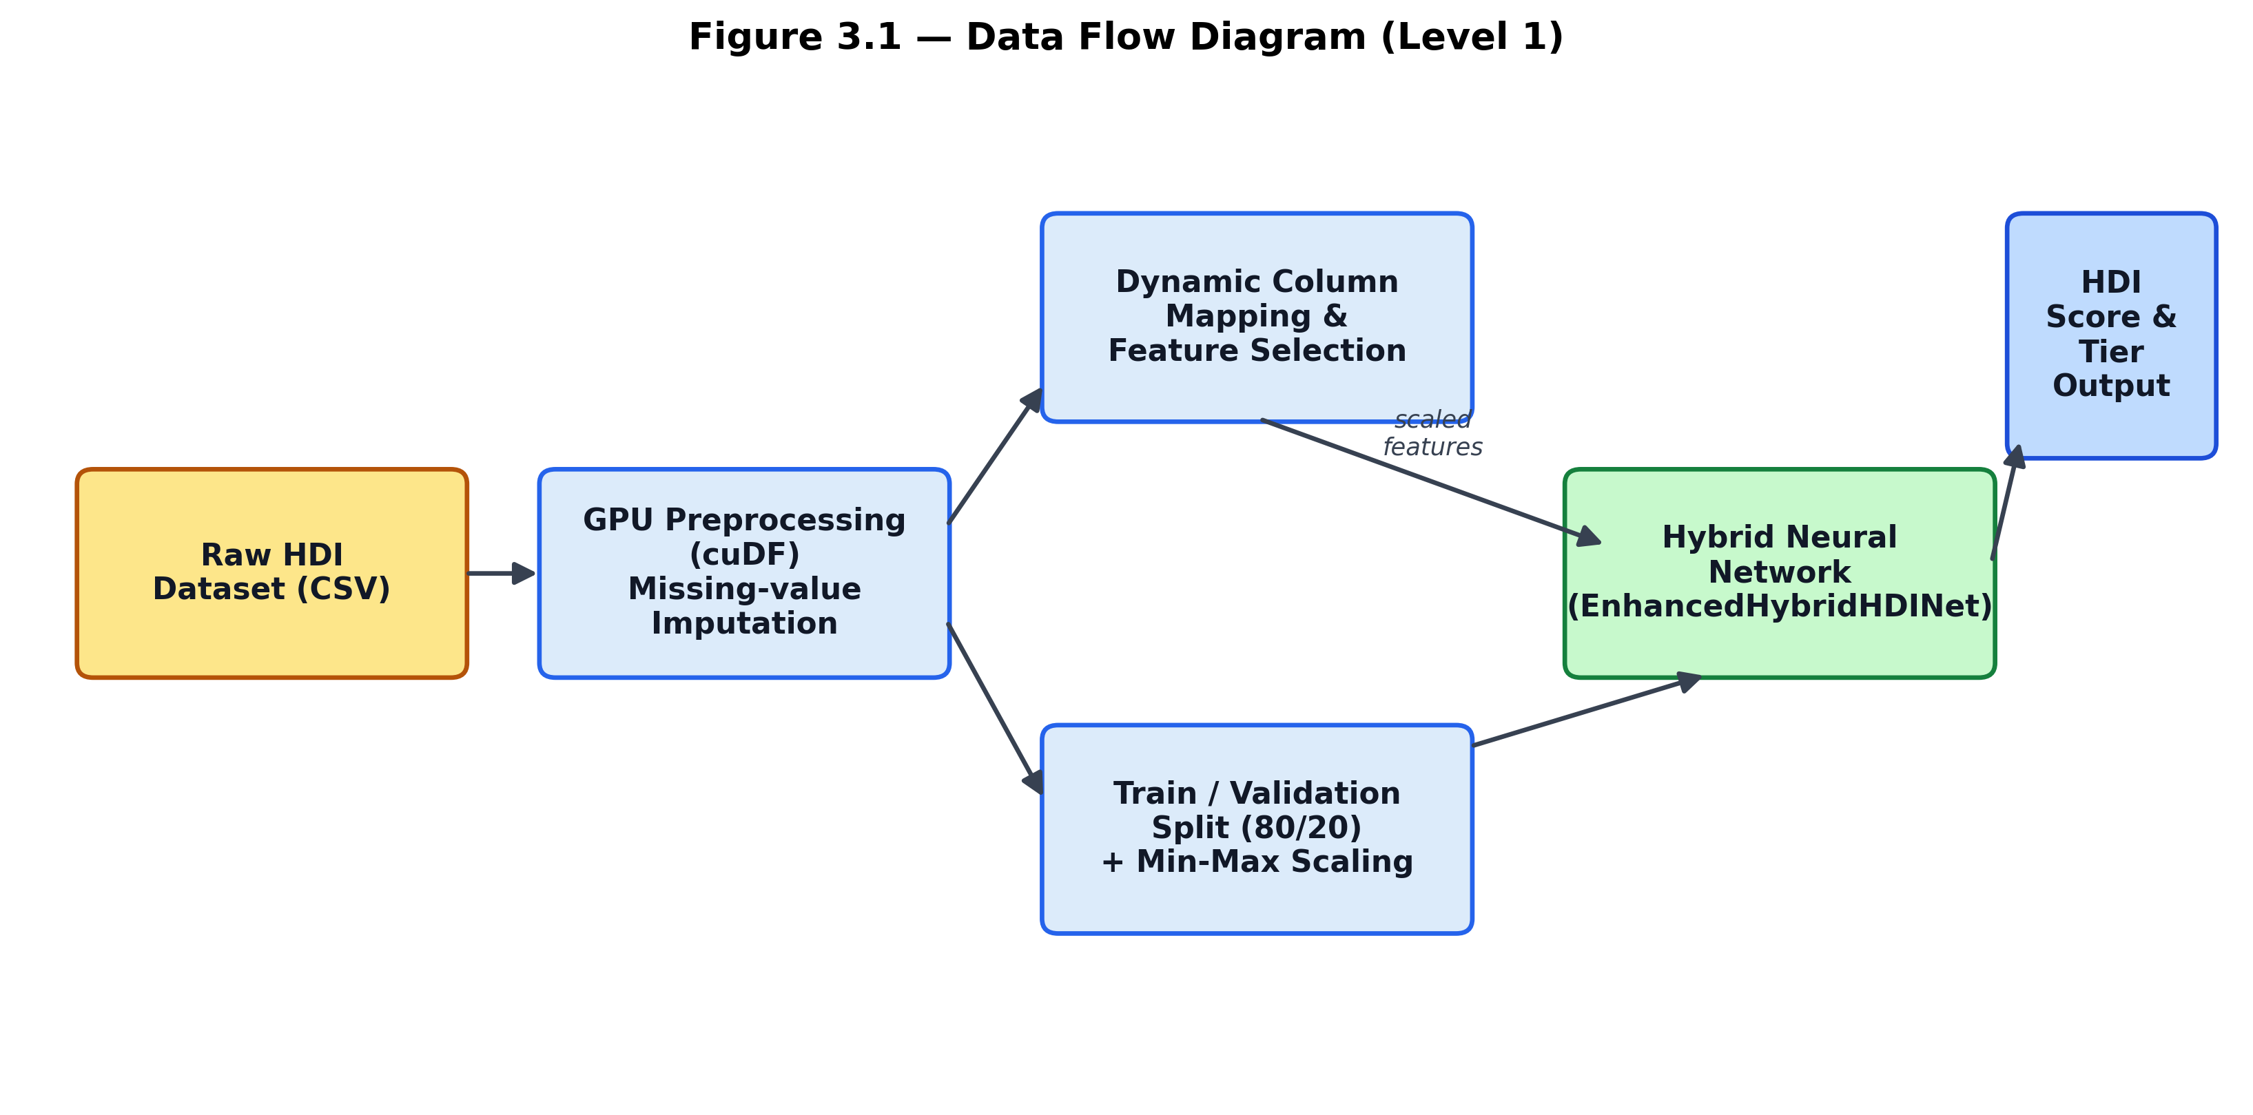
Figure: Data Flow Diagram — Raw dataset → GPU preprocessing → feature mapping & scaling → hybrid neural network → HDI score & tier output.

